**15. Create a script with one variable named badly (like X) and run pylint to see the warning. Rename it to follow lowercase_style and rerun pylint**

1. **Pylint_basics_test.py**

# Pylint basics test

X = 5

Pylint output

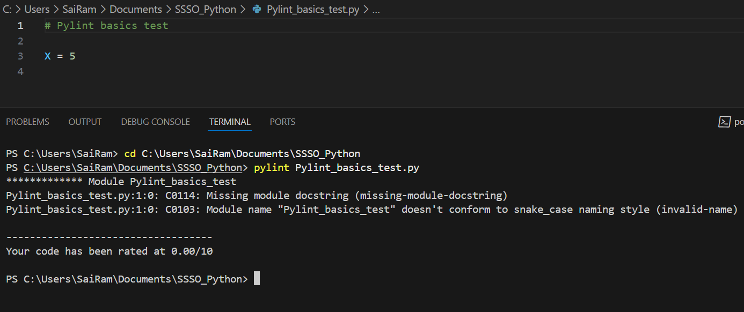

B. Rename file to follow naming convention **pylint_basics_test.py**

and add doc string and then re run pylint

# Pylint basics test

"""

create a variable x and assign a value

"""

X = 5

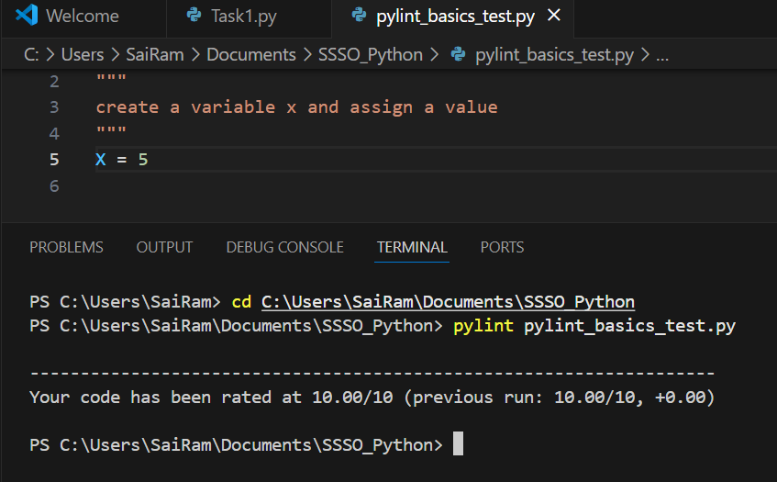

C. Change the variable naming convention and re run pylint

# Pylint basics test

"""

create a variable x and assign a value

"""

x = 5

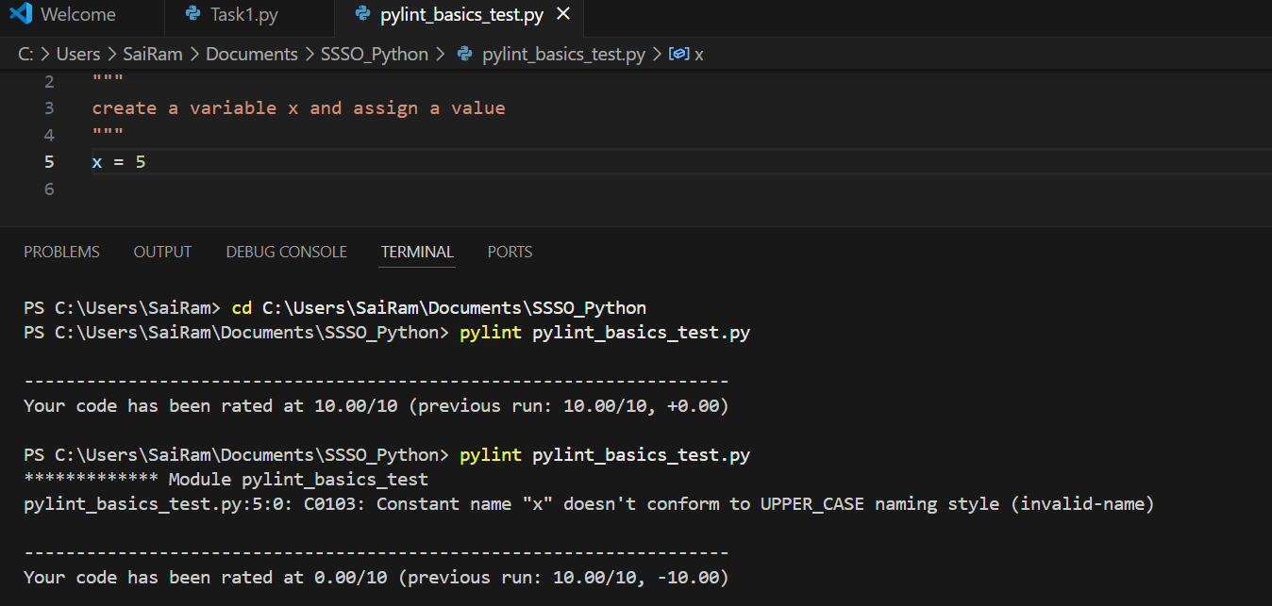

**16. Use sys.argv to accept one word from the command line and print it back. (Run: python echo.py hello).**

Step1 : Create a script to use sys.argv

# echo.py

"""

This is a sample script to read command line input

"""

import sys

# Check if the user provided a word

if len(sys.argv) < 2:

    print("Enter input in the format:")

    print("python echo.py <word>")

else:

    word = sys.argv[1]

    print("You entered:", word)

Step2 : Run the script in CLI

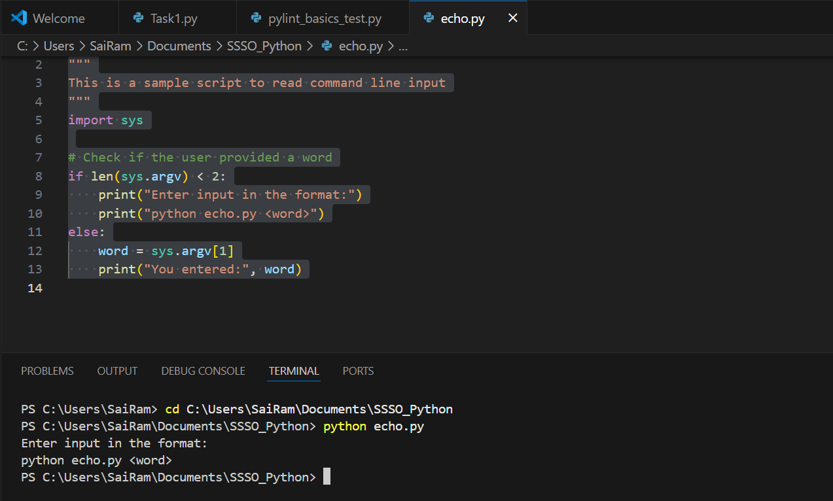

Step 3 Enter an input word in CLI while running the script

